
Onyx

Gateway Proxy Deployment Guide
Version 7.9

February 2020
Copyright © 2017 Avolin. All Rights Reserved. The information provided by Avolin in this document is for informational purposes only, without representation or warranty of any kind, and Avolin shall not be liable for errors or omissions with respect to the information. The only warranties for Avolin products and services are those set forth in the express warranty statements accompanying such products and services, if any, and nothing herein shall be construed as constituting an additional warranty. No part of this document shall be reproduced or transmitted in any form or for any purpose without the express written permission of Avolin. The information contained herein may be changed without prior notice. Some products marketed by Avolin contain proprietary software components of other software vendors. Avolin and other Avolin products and services referenced herein as well as their respective logos are registered trademark or trademarks of Avolin or its affiliated companies.
Contents
Introduction 1
Abbreviations Used 2
Onyx Components and Deployment Topology 3
Corporate Network 4
Onyx Gateway Service Proxy 5
Secure Communication Between OGS Proxy and OGS MobileServer 6
Onyx internal Network Components 7
OGS Proxy Installation 8
Installing Onyx Gateway Service Proxy 9
Silent Installer - Onyx Gateway Service Proxy 24
OGS Proxy Configuration 25
OGS Proxy without Authentication 25
Secure Socket Layer 26
Authentication OGS Proxy to OGS Server 27
OGS Server Address, Application, Site and Language 28
OGS Server 29
OGS Proxy Authentication 30
OGS Proxy Authentication - NTLM 31
Secure Socket Layer 31
Authentication OGS Proxy to OGS Server 32
OGS Server Address, Application, Site and Language 33
OGS Server 34
OGS Proxy Authentication – Basic Authentication 35
Secure Socket Layer (SSL) 35
Authentication OGS Proxy to OGS Server 36
OGS Server Address, Application, Site and Language 37
OGS Server 38
OGS Proxy with Multiple OGS Server 39
Post Changes 40

Introduction
This document provides an overview of the high-level components of Onyx and the deployment scenario with the demilitarized zone (DMZ). This document assumes that the network topology of each and every corporate organization is unique, and thus intends to provide information on a generic deployment of Onyx components.
The DMZ network is part of the corporate network that is outside the directory services. The resources within the DMZ network are not part of the internal network. Any request from the internet is to be handled in this network, for which a first layer of security is provided.
Note: OGS Proxy and OGS Server infrastructure allows user level authentication on both Onyx as well as windows.

Abbreviations Used
The following table explains the abbreviations used in this document
Abbreviation | Description
OGS | Onyx Gateway Services
OGS Proxy | Onyx Gateway Services Proxy
ONS | Onyx Notification System
OEDB | Onyx Enterprise Database
OEAS | Onyx Enterprise Application Services

Note: All the servers mentioned in the document can be load-balanced. That is, OGS, OGS Proxy, and OEAS.

Onyx Components and Deployment Topology
This section covers the Onyx components and their deployment.
Corporate Network
The following diagram shows how a device from outside the corporate network can access resources within the network.
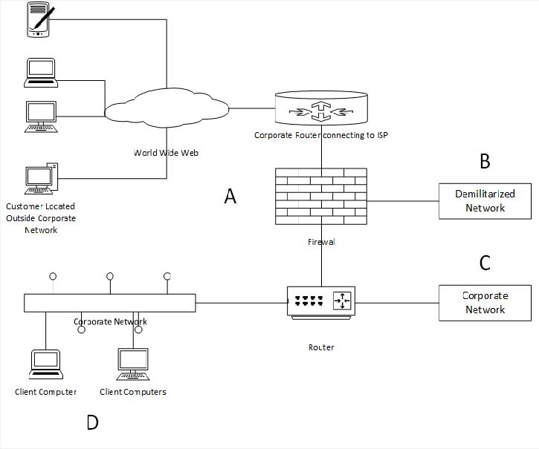
Mobile devices external to the corporate network interact with a Public IP or domain. The ISPs and the DNS will route the request to the Public IP address in the corporate network. The firewall/routers within the corporate network will forward the incoming requests to a system within the corporate network.
The firewall is configured to work with three or more networks. For example, in the diagram the firewall is connected to the Public Address IP, DMZ, and an internal network.
All communication from DMZ to the internal network should be monitored and configured using the firewall.
Onyx Gateway Service Proxy
Onyx Gateway Service Proxy Server, also referred to as OGS Proxy, should be configured to listen to requests from the internet. Install the OGS Proxy in a web server in the DMZ Zone. The OGS Proxy works on the HTTP protocol and should be hosted on Internet Information Services (IIS) 7.5. The OGS Proxy supports the Secure Socket Layer (SSL) HTTPS communication and the default port is 443.
The following diagram shows the OGS Proxy in DMZ:
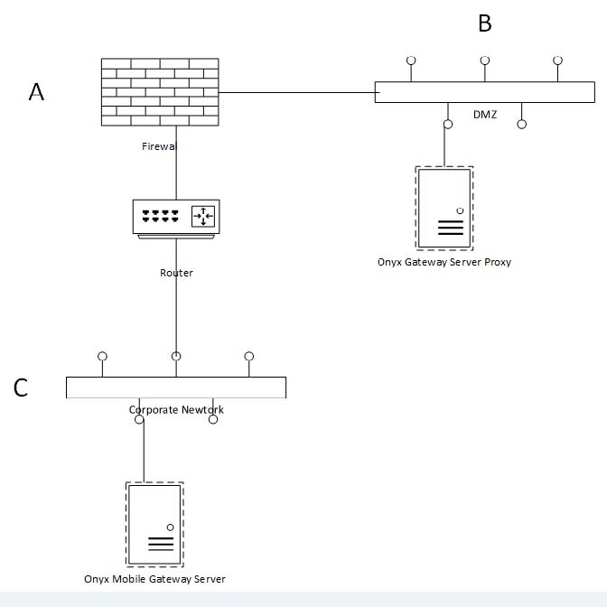

Secure Communication Between OGS Proxy and OGS MobileServer
The OGS Proxy Server interacts with the Onyx Mobile Gateway Server, which is in the internal network that supports SSL with Windows authentication. The Onyx Mobile Gateway Server exposes services for users who are part of the directory service. The OGS Proxy uses the domain credentials (configured in the config file) to interact with the OGS Mobile server with Windows Authentication on SSL. The user credentials are sent as 64bit encoded text over SSL to the OGS Mobile Server.

Onyx internal Network Components
The following diagram shows the OGS and OGS Mobile server within the corporate network.
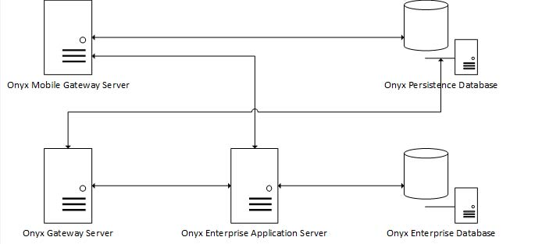
The OGS Mobile server is a replica of the OGS server with a transport layer security enhancement. Any application trying to interact with the OGS Mobile Server will be authenticated using the Windows authentication credentials.
Both the OGS server and the OGS mobile server have direct connectivity to the Onyx Persistence database (contains the Onyx Notification and Navigator Data) and interact with the OEAS server using the COM+ Proxy.
OGS Proxy Installation
This section provides information on the setup and configuration of OGS Proxy and OGS Server. The OGS Proxy is needed where the OGS Server does not have access to the database server or OEAS Server. The OGS proxy can interact with the OGS Server with 3 different options and this document helps in configuring.
Note: OGS Proxy should always support communication on Secure Socket Layer, but support for plain HTTP protocol is supported.

Installing Onyx Gateway Service Proxy
To Install Onyx Gateway Service Proxy for Windows service:
- Copy the Onyx Gateway Service folder to your OEAS server from Platform Components > Application Server OEAS > OGS Proxy from the Onyx 7.6 installation package.
- Open the OGS Proxy folder on your OEAS server, and then double-click OGS Proxy setup file.
The Welcome window appears.
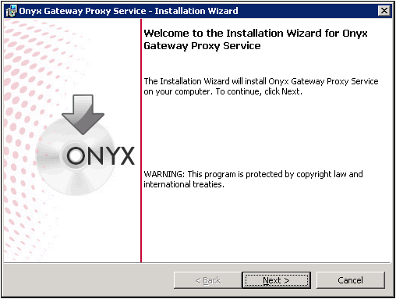
- Click Next.
The Setup Type window appears.
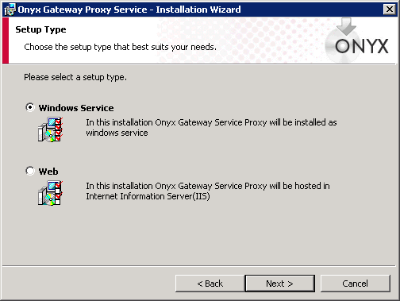
- Click the setup type option as windows service, and then click Next.
The Logon Information window appears.
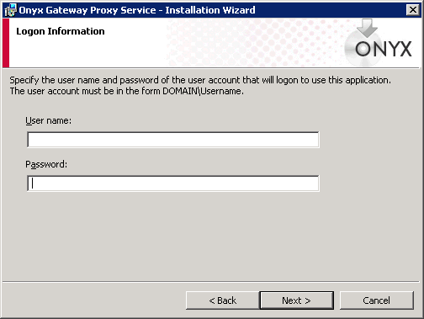
- Type the required Username in the Domain\Username format and Password for OGS proxy to use.
- Click Next.
The Port Information window appears.
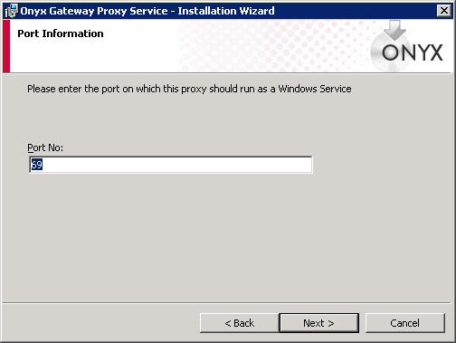
- Type the port number. The default is set to 69.
- Click Next.
The OGS Server Information window appears.
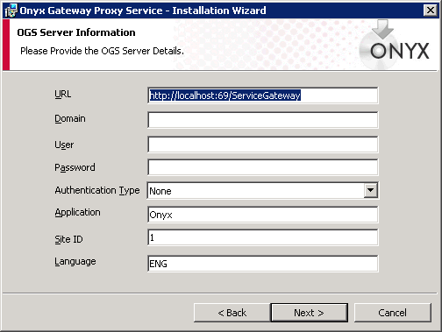
- Do the following:
- URL. Type the service url to connect to the OGS server.
- Domain. Type the domain name
- User. Type the username
- Password. Type the password
- Auth. Type. Type the authentication type to connect to OGS Server. The options are None, NTLM, Windows, and Basic
- Application. Type Onyx Application Name
- Site Id. Type Onyx Application Site Id
- Language. Type Onyx Language Id
- Click Next.
The Destination Folder window appears.
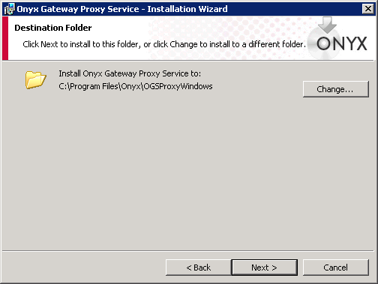
- Retain the default path or click Change to specify the required path.
Click Next.
The Start Copying Files window appears.
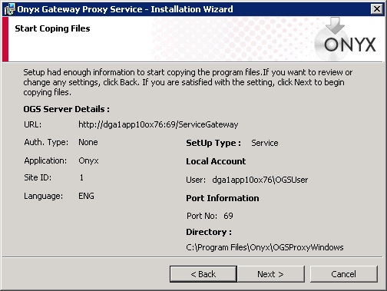
- Verify that the details displayed are correct, and then click Next. (Click Back to make required corrections.)
The Ready to Install the Program window appears.
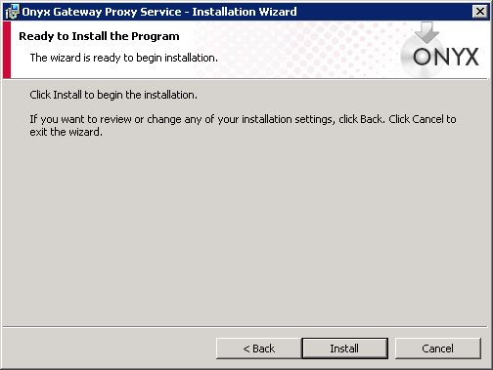
- Click Install to begin the installation.
After the installation is complete, the Installation Completed window appears.
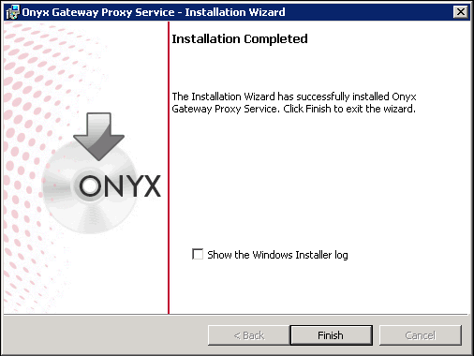
- Click Finish.

To Install Onyx Gateway Service Proxy for IIS:
- Copy the Onyx Gateway Service folder to your OEAS server from Platform Components > Application Server OEAS > OGS Proxy from the Onyx 7.6 installation package.
- Open the OGS Proxy folder on your OEAS server, and then double-click OGS Proxy setup file.
The Welcome window appears.
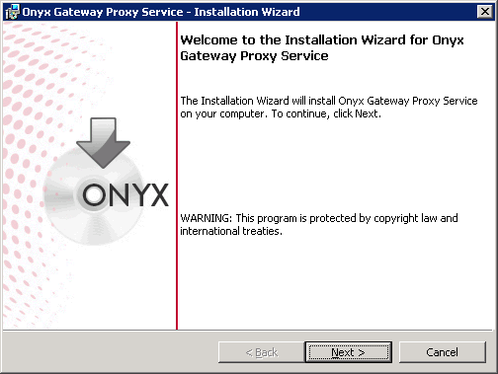
- Click Next.
The Setup Type window appears.

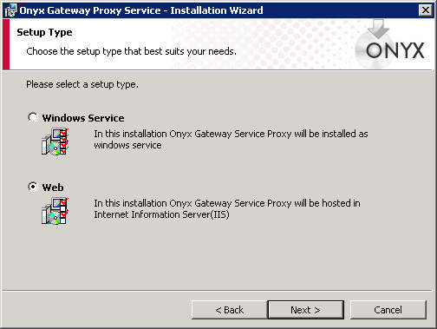
- Click setup type option as windows service, and then click Next.
- Click Next.
The Onyx Gateway Service Proxy window appears.
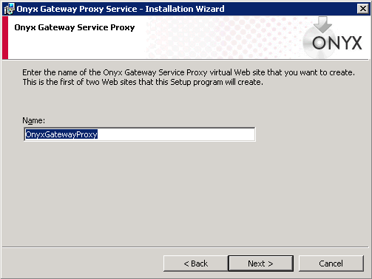
- Retain the default name or type the new name.
- Click Next.
The OGS Server Information window appears.
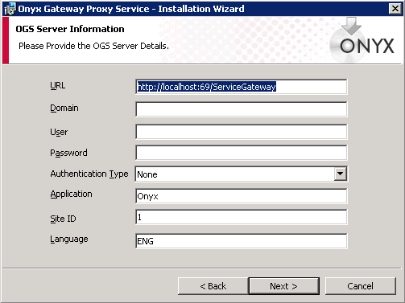
- Do the following:
- URL. Type the service url to connect to the OGS server.
- Domain. Type the domain name
- User. Type the username
- Password. Type the password
- Auth. Type. Type the authentication type to connect to OGS Server. The options are None, NTLM, Windows, and Basic
- Application. Type Onyx Application Name
- Site Id. Type Onyx Application Site Id
- Language. Type Onyx Language Id
- Click Next.
The Destination Folder window appears.
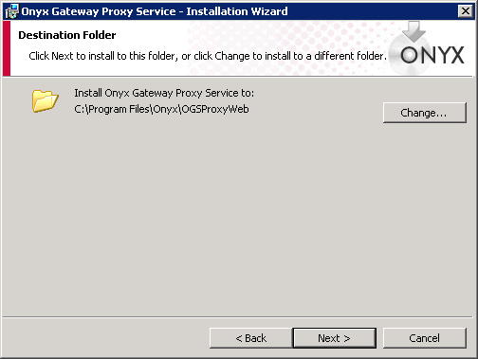
- Retain the displayed path or change where it needs to be installed.
- Click Next.
The Start Copying Files window appears.
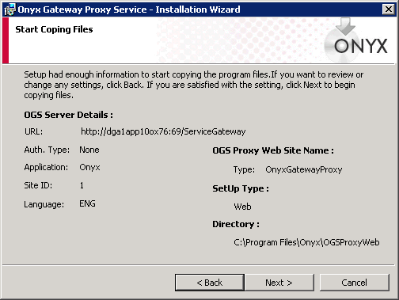
- Verify the details and then click Next.
The Ready to Install the Program window appears.
- Click Install.
After the installation is completed, the Installation Wizard Completed window appears.
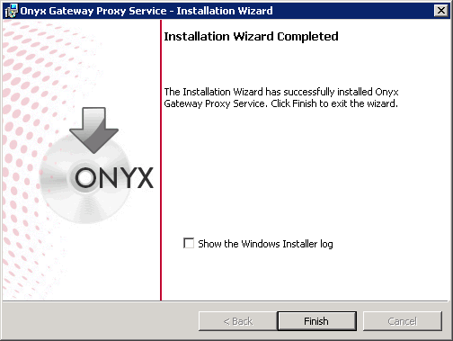
- Click Finish.
Silent Installer - Onyx Gateway Service Proxy
Parameters | Description | Default Value | Required
/s | Silent Install |  | Yes
/v""/l*v C:\OGSProxy.log"" | To Create Log File |  | Yes
/v""INSTALLDIR=\""C:\Program Files\Onyx\"""" | Installation Path | C:\Program Files\Onyx | No
/v""OGSPROXYPATH=\""C:\Program Files\Onyx\OGSProxyWindows\"""" | Installation Path for Windows Service | C:\Program Files\Onyx\OGSProxyWindows | No
/v""OGSPROXYPATH=\""C:\Program Files\Onyx\OGSProxyWeb\"""" | Installation Path for IIS Host | C:\Program Files\Onyx\OGSProxyWeb | No
/v""SERVICETYPE=Service"" | Install OGS Proxy as Windows Service | 1 | No
/v""SERVICETYPE=Web"" | Install OGS Proxy as IIS Host |  | Yes
/v""SERVICEUSERNAME=domainname\username"" | Log on Service User name |  | Yes
/v""SERVICEPASSWORD=password"" | Log on Service Password |  | Yes
/v""AUTHENTICATIONTYPE=None"" | Authentication Type - None,Basic,NTLM,windows |  | Yes
/v""APPLICATION=Onyx"" | Logical Application Name |  | Yes
/v""SITEID=1"" | Site ID | 1 | No
/v""LANGUAGE=ENG"" | Language |  | Yes
/v""/qn/a"" | Run as Administrator |  | Yes

OGS Proxy Configuration
OGS Proxy without Authentication
The following diagram explains the OGS Proxy and OGS Server.
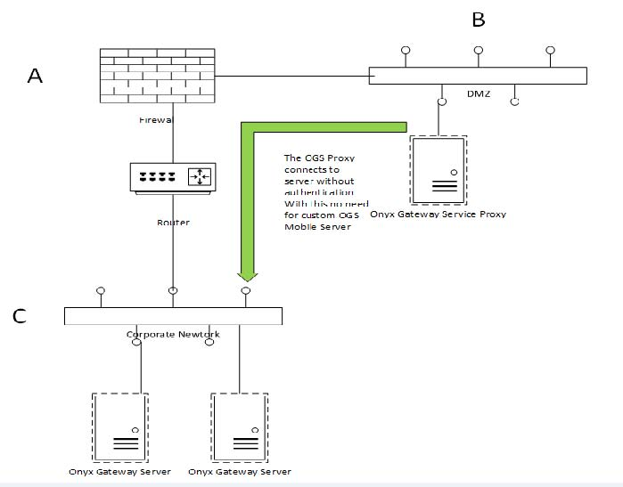
The OGS Proxy is deployed in DMZ network, on IIS with port 443, 80 or on windows service on port 69. By default the OGS Proxy will support HTTPS only, but this can be changed by modifying the configuration.
With this configuration there is no need for separate set of OGS Mobile server.
Secure Socket Layer
To support the SSL on OGS proxy, the following configuration is required: By default the OGS Proxy is installed with Transport Layer Security Enabled.
For proxy deployed in IIS:
Update the web.config file.
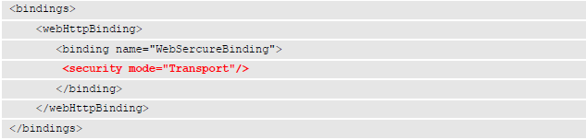
Note: If the above highlighted text is commented, uncomment it.
For proxy deployed as Windows Service:
Update the Onyx.GatewayProxy.WindowsService.exe.config file.
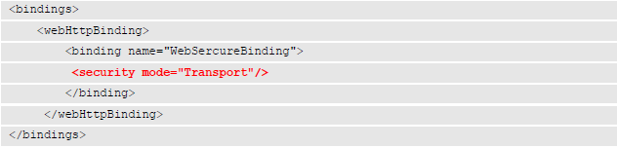
Note: If the above highlighted text is commented, uncomment it.
Base address of the proxy should have https connection type:
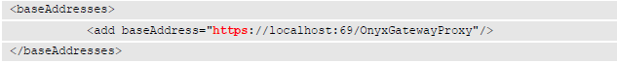

Authentication OGS Proxy to OGS Server
To apply no security between the Proxy and the server the authentication mode should be set to “None” in the configuration file.
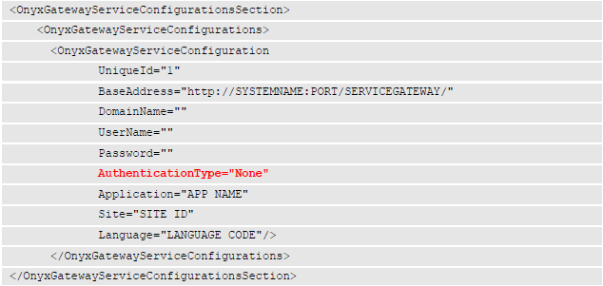
OGS Server Address, Application, Site and Language
The proxy interacts with the OGS server which is deployed in internal network. The following details are required in the configuration.
- UniqueId: Provide a unique Id, can be alpha numeric (should be unique if multiple OGS Servers are configured).
- BaseAddress: Provide the Base URI of the OGS Server (should have ServiceGateway in the URI).
- Application: Provide the Onyx Application name in the Application attribute.
- Site: Provide the Onyx Site Id in the Site attribute.
- Language Provide the Onyx Language code.

Note: Refer to the highlighted text only.
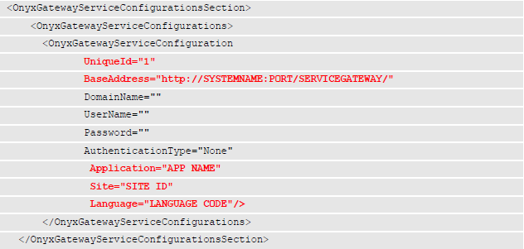
OGS Server
The OGS Server should be configured to service any request from OGS Proxy, if a firewall is blocking it should be removed. (To be done by system administrators).
Note: The highlighted text should be commented. (By default OGS Server serves any requests without authentication).
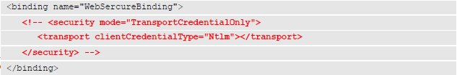
Note: Comment the following highlighted text:
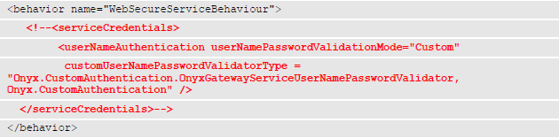
OGS Proxy Authentication
The following diagram explains the OGS Proxy and OGS Server with authentication. The communication between OGS Proxy to the Server support involves multiple authentication, which is Basic and NTLM.
Basic Authentication provides custom windows authentication when there is no support for NTLM.
To enable authentication between proxy and server, both servers will undergo changes. The OGS Server and proxy server should have similar configuration to authenticate the security tokens from the proxy. Since most of the OGS servers currently deployed do not provide transport layer security with credentials, this requires a new OGS server to support it. We can name this as OGS Mobile Server.
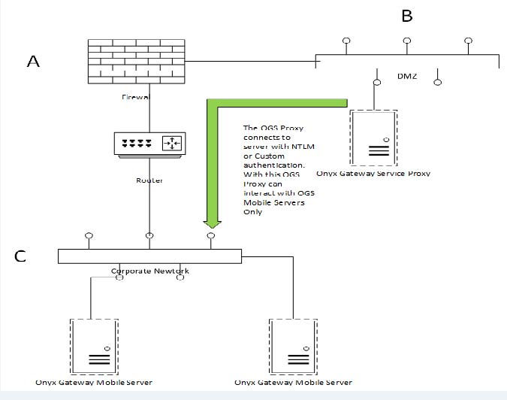
OGS Proxy Authentication - NTLM
Secure Socket Layer
To support the SSL on OGS proxy, the following configuration is required: By default the OGS Proxy is installed with Transport Layer Security Enabled.
For proxy deployed in IIS:
Update the web.config file.
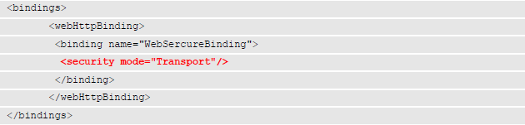
Note: If the above highlighted text is commented, uncomment it.
For proxy deployed as Windows Service:
Update the Onyx.GatewayProxy.WindowsService.exe.config file.
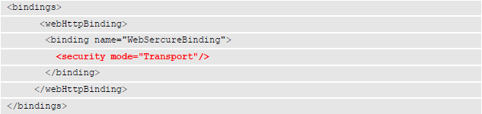
Note: If the above highlighted text is commented, uncomment it.
Base address of the proxy should have https connection type:
Authentication OGS Proxy to OGS Server
By default OGS will interact with the OGS Server without authenticating the caller. To apply NTLM security between the Proxy and the server, the authentication mode should be set to “Ntlm” in the configuration file and user credentials provided. The password attribute should have an encrypted password, which can be generated using “PassEncrypt.exe” (available in the utilities folder).
Note: Refer to highlighted text only.
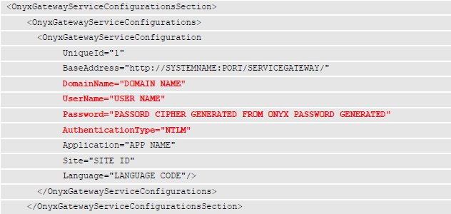
OGS Server Address, Application, Site and Language
The proxy interacts with the OGS server which is deployed in internal network. The following details are required in the configuration.
- UniqueId. Type a unique Id, can be alpha numeric (should be unique if multiple OGS Servers are configured).
- BaseAddress. Type the Base URI of the OGS Server (should have ServiceGateway in the URI).
- Application. Type the Onyx Application name in Application attribute.
- Site. Type the Onyx Site Id in Site attribute.
- Language. Type the Onyx Language code.
Note: Refer to highlighted text only.

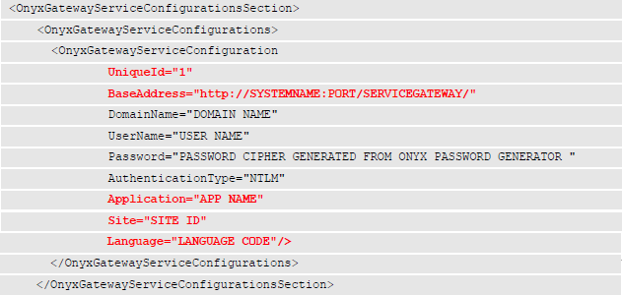
OGS Server
The OGS Server should be configured to service any request from OGS Proxy with NTLM authentication, if a firewall is blocking it should be removed. (To be done by system administrators). Following are the changes required in the configuration file:
Note: The highlighted text should be uncommented.
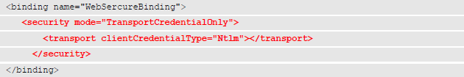
Note: Comment the following highlighted text:
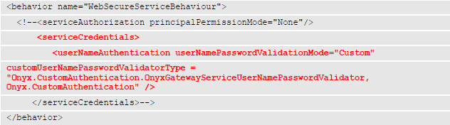

OGS Proxy Authentication – Basic Authentication
Secure Socket Layer (SSL)
To support the SSL on OGS proxy, following configuration is required. By default the OGS Proxy is installed with Transport Layer Security Enabled.
For proxy deployed in IIS:
Update the web.config file.
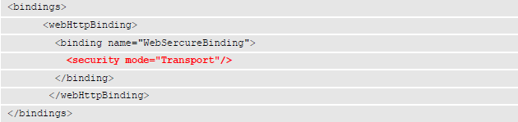
Note: Comment the following highlighted text:
For proxy deployed as Windows Service:
Update the Onyx.GatewayProxy.WindowsService.exe.config file.
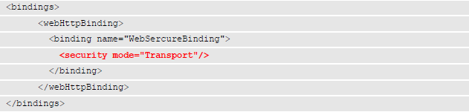
Note: If the above highlighted text is commented, uncomment it.

Base address of the proxy should have https connection type:
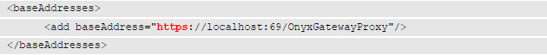
Authentication OGS Proxy to OGS Server
By default OGS will interact with OGS Server without authenticating the caller. To apply Basic security between the Proxy and the server the authentication mode should be set to “Basic” in the configuration file and the user credentials provided. The password attribute should have an encrypted password, which can be generated using ““PassEncrypt.exe” (available in the utilities folder).
Note: Refer to highlighted text only.
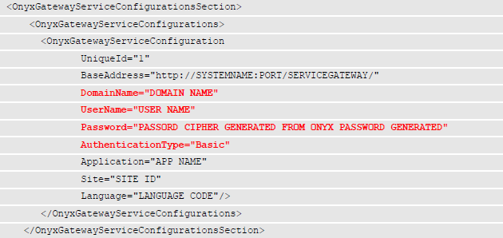
OGS Server Address, Application, Site and Language
The proxy interacts with the OGS server which is deployed in internal network. The following details are required in the configuration.
- UniqueId. Type a unique Id, can be alpha numeric (should be unique if multiple OGS Servers are configured).
- BaseAddress. Type the Base URI of the OGS Server (should have ServiceGateway in the URI).
- Application. Type the Onyx Application name in Application attribute.
- Site. Type the Onyx Site Id in Site attribute
- Language. Type the Onyx Language code
Note: Refer to highlighted text only.
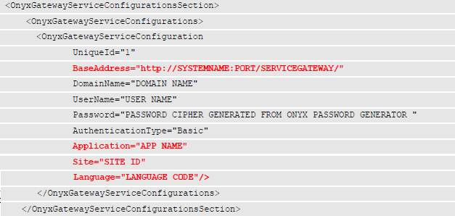

OGS Server
The OGS Server should be configured to service any request from OGS Proxy with Basic authentication, if a firewall is blocking it should be removed. (To be done by system administrators). Following are the changes required in the configuration file:
Note: The following highlighted text should be uncommented.
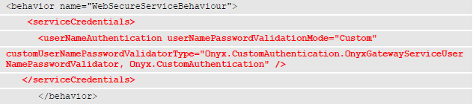
Uncomment the following highlighted text and set the “ClientCredentialType=Basic”.
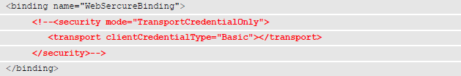

OGS Proxy with Multiple OGS Server
OGS proxy can handle multiple OGS Server requests. The requests are based on parameters:
- Application Name
- Site Id
- Language Code
The following is an example of multiple OGS Server.
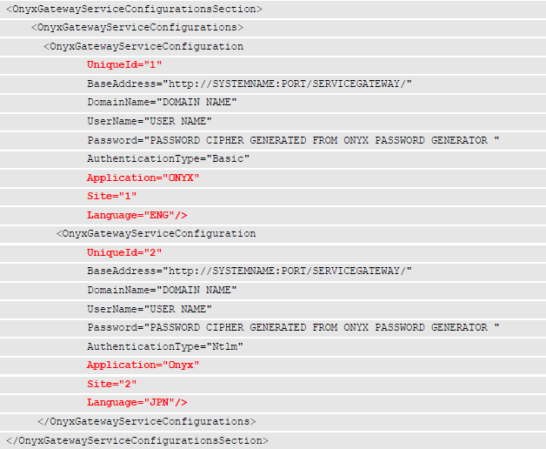
Post Changes
Any changes done in the configuration should follow the below steps.
- Restart the OGS Proxy Server. If IIS restart Application Pool for the service.
- Restart OGS Server.

